**Aidan Brown**

**GEOG 501 Fall 2023**

# Deliverable 1

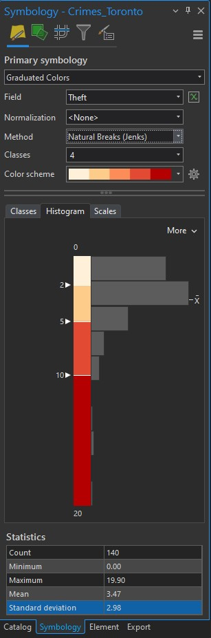

# Deliverable 2

I chose to use Natural Break as the classification method with the crime type. I am looking at this with the perspective of a home buyer, or someone that wants to start a business in the Toronto area, as these statistics are very important to take into account when purchasing property. Using natural breaks clearly illustrates the large areas of discrepancy versus the smaller outlier areas, as I want the minimum and maximum values to stand out on the map layout.

# Deliverable 3

Map layout of crime rates in Toronto neighborhoods:

